Quote
Name
Adresse
City, Postcode

Version 1.0 – DD.MM.YYYY

Performance Description

In this quote, you will find information relating to the technical implementation of your Loxone Smart Home. The performance description is based on the essential components that we recommend be installed in your smart home. This allows you to control your lighting, shading, heating, burglar alarm, multiroom audio and much more. The quote includes hardware, cabling, installation and configuration.

Automation
The Automation category includes all Loxone components that are located in the central cabinet/s. These components form the basis for the entire installation.


 | Intelligent automation and intuitive control will be processed by the Loxone Miniserver.
 | The Loxone system will be fully-scalable and future-ready thanks to an unparalleled ecosystem and a range of open interfaces.
 | 100% Cloud-free – No data leaves your home. All logic is processed within your own four walls so you can be assured of privacy

Price: £ 0,000.00

Control
A real smart home simpy takes care of important functions by itself.
If you want to intervene manually, you can do so at any time with just a tap.

Simple and intuitive control via a Loxone Touch or Touch Pure.
Free app for control via your smartphone, tablet or PC.
Barbecue thermometer that controls your smart home -
the Touch & Grill Air.
Bedside nightlight, alarm clock and alarm light -
the Touch Nightlight Air.

Price: £ 0,000.00

The Loxone Switch Standard
A Loxone smart home that features the Loxone Switch Standard benefits from what is probably the most intuitive, user-friendly smart home control on the planet. All touch points in each room should have the same functions – far removed from the negative association of smart homes that are complicated to control and banks of switches that need labels.

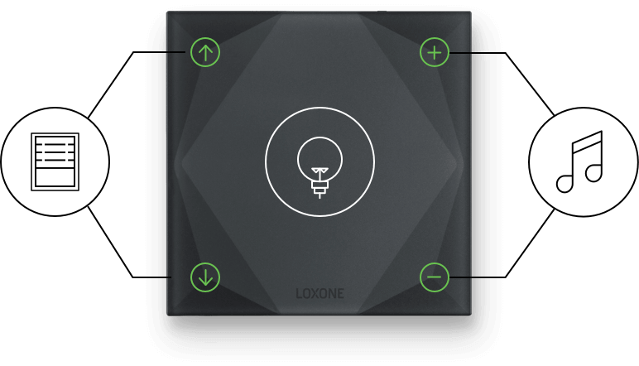
 | Single Click  With a single tap on the centre of a Touch Pure you can witch the lights on and scroll though predefined lighting moods.  You can control the volume and playback of the music, and the blinds by simply tapping on the respctive corner touch points.
 | Multiple Clicks  Double-tap on the top right touch point to change the music source, souble-tap the bottom right to stop the music.  A double-tap on the centre touch point will turn the entire room off.  On predefined switches, a triple-tap on the ceentre touch point switches off the entire house and arms the burglar alarm.  In the bedroom, a triple tap on the centre touch point of a beside Touch will activate the Good Night Mode..

Shading
The shading is automatically adjsuted according to the position of the sun and the interior temperature. For Venetian blinds and external blinds, the slat position is automatically adjusted according to the position of the sun..



Protection against both loss of heat and overheating.
The Weather Station detects storm or frost and can protects your external shading from damage.
Suitable for a wide variety of shading such as Roman and Venetian blinds, external blinds, roller shutters, awnings etc.

Price £ 0,000.00

Climate Control
The temperature can be set individually at room level. Comfort temperatures and heating & cooling schedules can be individually adjusted. If appropriate Door & Window contacts are installed, the temperature is set to Overheat or Frost Protection when the window or door is open.


Reduce energy cost and increase your level of comfort.
Self-learning zoned heating that knows when to turn on ensuring the comfort temperature is reached at the desired time.

Price: £ 0,000.00

Motion Sensors / Presence Detection
One of the most important functions in the smart home is the detection of movement or presence. The Motion Sensors detect presence in the room allowing for the intelligent automation of lighting, heating and cooling where applicable. In some locations, presence detection can be used to control your multiroom audio system (if present). Motion Sensors is essential for the burglar alarm functionality.


Lights automatically turn if needed whenever you enter a room.
Adding crucial functionality to the burglar alarm.
Demand-driven heating & cooling automation.
Determining presence and motion for various functions.
Motion-activated multiroom audio.

Price: £ 0,000.00

Security
Having smart security as part of your smart home is about more than just burglary protection. Your smart home watches over you and your family while at the same time protects itself against potential hazards such as the escape of water.


Alarm functionality as part of your smart home ecosystem.
Fire and Water alarm overview.
Enhanced burlar alarm functionality with Door & Window contacts.

Price: £ 0,000.00

Access
With intuitive integrated access control from Loxone, your burglar alarm is automatically deactivated when it knows that you have arrived home. Additionally, with the Loxone Intercom, you’ll get a notification when you have a visitor; allowing you to also see and speak with them, all via the app


Easy access via user-defined access codes or encrypted Key Fobs or NFC Smart Tags.
Management of access permissions, access codes and access statistics via the Loxone App.
Wireless remote control for your smart home – the Remote Air.
A fully integrated intercom system.

Price: £ 0,000.00

Lighting
With the help of Motion Sensors, the lighting is automated and adjusts to the needs of the residents. Combine this intelligent automation with a variety of lighting sources and lighting groups to create individual lighting moods – allowing you to completely change the look and feel of any room in your home.
.


Efficient and durable LED lighting elements.
Individually addressable and customisable lighting. The brightness levels, temperature and light colour can be individually adjusted.

Price: £ 0,000.00

Multimedia

The Loxone Multiroom Audio solution makes it possible to play different music in different rooms, or to play the same music synced throughout multiple rooms. The Multiroom Audio system can also be used as a doorbell, burglar alarm, alarm clock and to receive text-to-speech notifications. In addition, other multimedia functionality can be extended to devices such as your television.

Multiroom audio fully integrated into your smart home.
Burglar alarm, wake up alarm, and door chime included.
Incorporate TVs and other infrared-controlled devices.
Intuitive control via the Loxone Touch switches and the Loxone apps.

Price: £ 0,000.00

Accessories
Useful accessoriies for your Loxone smart home that work perfectly with existing Loxone components.

Intelligent switching of electrical appliances with integrated power measurement – the Smart Socket Air.

Price: £ 0,000.00

Total excl. VAT |  | £ 0,000.00
- VAT | 20% | £ 0,000.00
Total incl. VAT |  | £ 0,000.00

