Loxone Wallbox 22kW 32A Tree

Statement of Compliance
The Electric Vehicles (Smart Charge Points) Regulations 2021
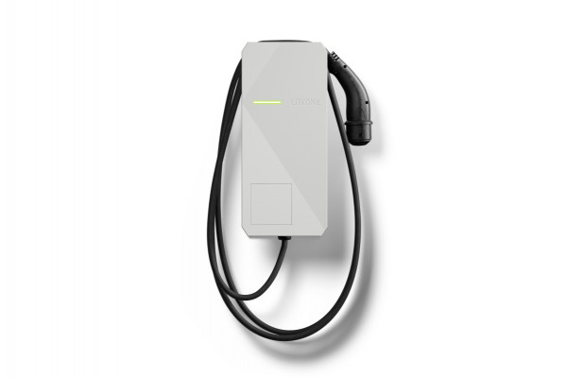

The seller,
Seller name | Loxone UK Ltd /  Loxone Electronics GmbH
Seller address | Station Road, Theale, Reading, RG7 4RA /  Smart Home 1, Kollerschlag, Upper Austria, 4154
declares under sole responsibility that the relevant charge point,
Charge point make | Loxone
Charge point model | Wallbox 22kW 32A Tree (Item No.: 100677)
Software version at point of sale | Latest firmware at point of manufacture
Compliance with Schedule 1 security requirements | Yes
Details of Demand Side Response (DSR) agreement if present | No agreement
Manufacturer name | Loxone
Manufacturer address | 1 Smart Home, Kollerschlag, Upper Austria, 4154
Date of sale | See invoice specific to each transaction
complies with the device-level requirements set out under the Electric Vehicles (Smart Charge Point) Regulations 2021, as detailed in the technical file (available on request).
Signature
Authorised to sign on behalf of seller
Name | Tyron Cosway
Date | 05.12.2025

